Hi Sue

You need to be in an Existing database before you can link a table. So open up an existing database and follow the instructions below.

Go to File Menu
To do this go to the menu bar and from the File menu. Select Get External Data and choose - Link tables see below.

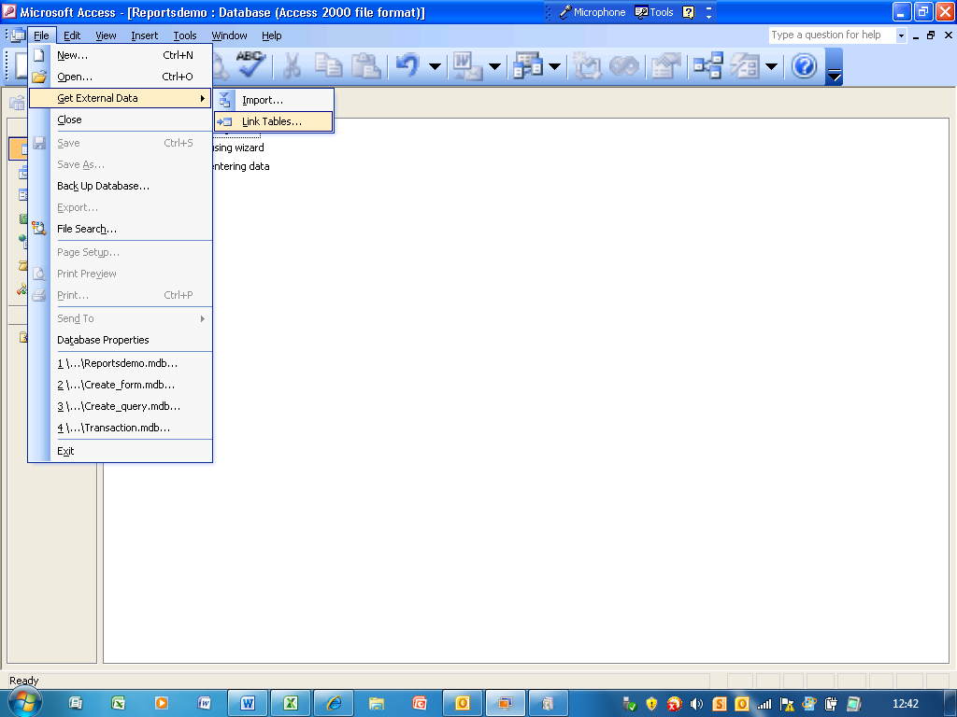

Selecting Database to link to – using link box
After clicking the link tables the box below will be displayed
You now need to navigate to the database you want to link to and click on the link button

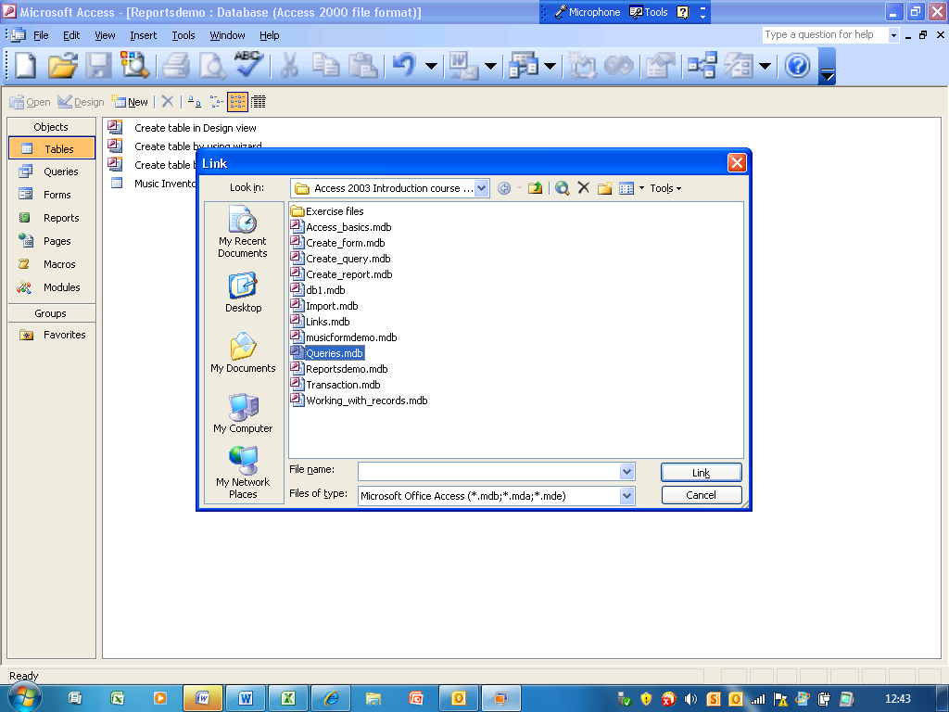

Selecting Tables from Database from Link tables box
When you click on the link button to select the database You will get the Link tables box below which will list the tables, queries, forms, and reports available in the database note the database I have selected only has tables.

There are no queries, reports in this database that is why only the tables tab is displayed.

Click on the table you want to link to or select all of the tables by clicking on the select All if you want to link to all of them.

You can press the Ctrl Key and left click with your mouse to select or deselect a table in the list below.

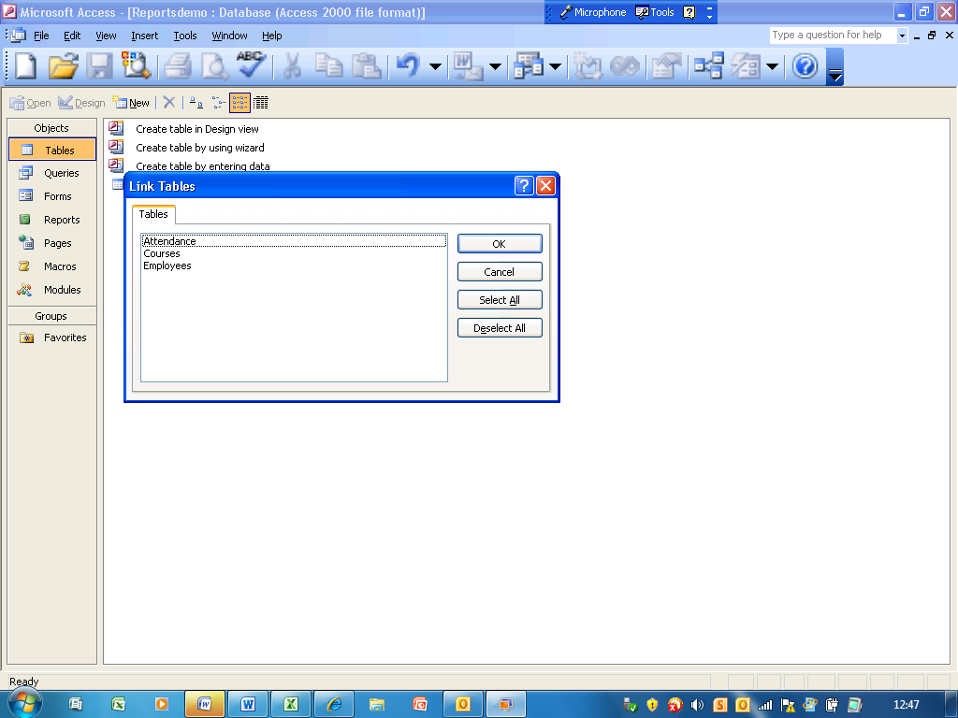

Selecting Table to Link to

I selected the Attendance table and now I need to click on OK to link it to my original database

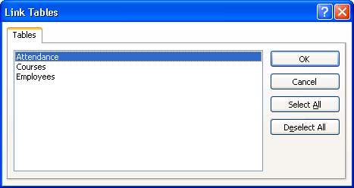

The Attendance table is now in my original database as a linked table. The blue arrow next to the table name denotes it is a linked table.

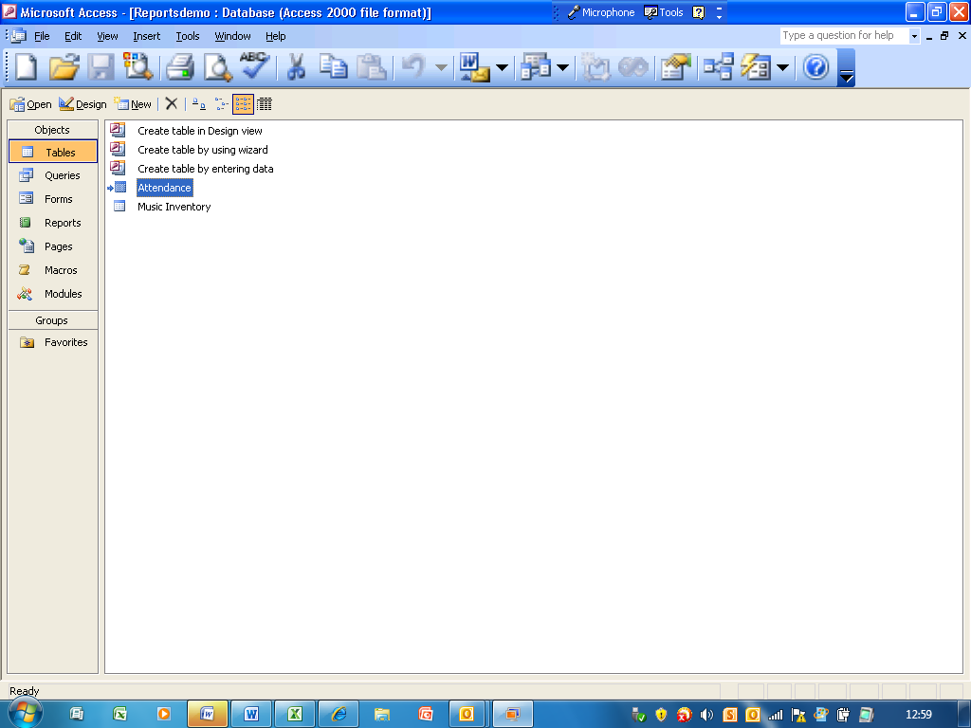
Updating a Linked Table - To update go to the Linked Table manager

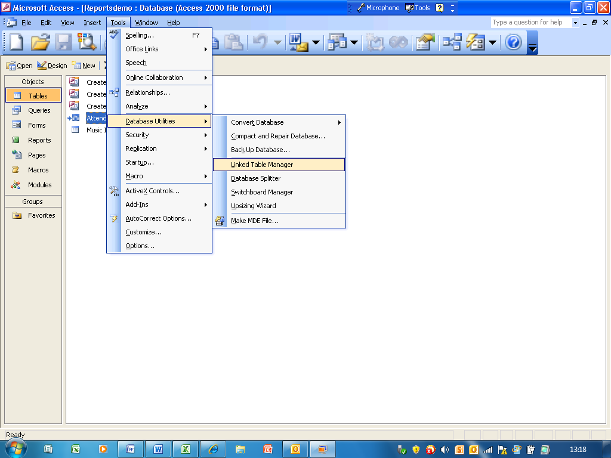

Note by default that a linked table is not checked to be updated. To update the table you need to check the box see below and click on OK.

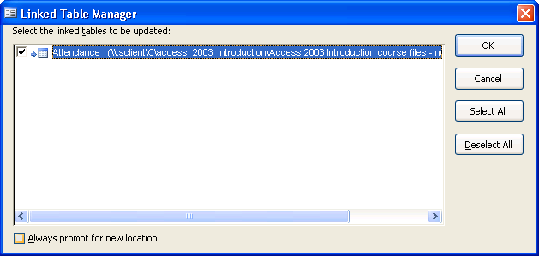

The box above displays the source of the linked table ( ie the database it comes from). To update the linked table in its source database click on the checkbox then click on OK. Once you click on OK note that the tick is removed. Note this should be done every time you wish to update the source database.

